Description | ​A simple application to help connect students and employers better
Version# | 1.0

Table of Contents
Functional Requirement
Inputs
Manually filling the form
Resume in PDF format
Key Assumptions
OS Support
OS User
OS Directories
Scheduler or CRONTAB Entries
Infrastructure or DBA Assistance Expectations
Schema Changes
Program Design
Program Logic
Acceptance Test Scenarios
Supporting Documents
Notes

Document Control

Document Revision History
Ajinkya | 18/Jan/2024 | Initial Draft

Document Review History
Reviewer | Review Date | ECO # Reviewed

Functional Requirement
Student Employment Management
Get the data from students and store it in a DB. Share the students’ qualifications with the potential employers. Share the student contact only if the employer is looking forward to hire or interview.

Students can be given a QR code to scan that redirects them to the Application website. The Home Page will ask them 2 options as follows:

- Fill the Form: If student selects “fill the form”, the data entered will be read and store it in our DB.
- Update the existing data: If the student is uploading the resume, data will be read through data scraping logic and a confirmation will be sent to the student to get a verification from the student if the scraped data is accurate.

Essential Inputs

Fill the form Manually

The student needs to enter the “required” fields and optional fields for any additional information

Upload the Resume

The student needs to have the resume in the form of PDF format to be uploaded into the portal

Key Assumptions & Constraints
- Data older than 6 months should be removed unless or until students manually update the status
- Compliance Area: Data Breach and Data Protection for students’ safety
- Students have a basic level of proficiency with technology and can navigate through the portal.
- Platform is Web browser dynamic and Mobile responsive.
- Application is scalable for future enhancements/feature inclusions.
- Unprocessed data will be input by the student which will require further processing/cleaning while loading/updating the DB Tables.

OS Support

--

Infrastructure or DBA Assistance Expectations

--

Schema Changes

--

Program Logic
- Student logs into the Home page of the application by scanning the QR code
- The home page consists of 2 options. The form will have 2 options –
  - (a) Filling the new form? For this option, student will have to enter through the email as it will be used as a record identifier to uniquely identify the student. Include a security question in the form to be used just in case if the student wants to update the data in future.
  - (b) Updating the existing data? For this option, student will have to answer a security question or will be sent a code to his/her email address to continue updating the data
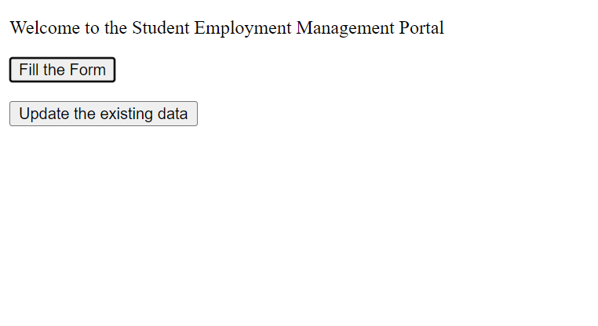
- Filling the new form – If the student selects this option, will be presented 2 options –
  - (a) Fill the form manually - If they select fill the form manually, we will simply take the data and store it in our DB.
  - (b) Upload your resume - If they are uploading their resume, we will scrap the data and load and send a confirmation to the student if the scraped data is accurate.
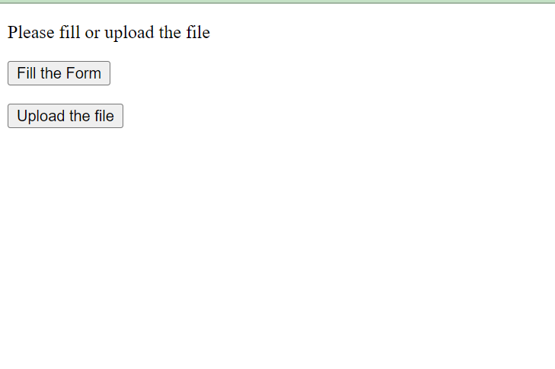
- User Interface - TBD
- Database : TBD
- DB Table Name – stud_det
Table Fields –
  - ID
  - First Name
  - Last Name
  - Phone number
  - Email
  - Address
  - Skillset
  - Gender
  - Ethnicity
  - Languages known
- DB Table Name – stud_acad
Table Fields –
  - Student ID
  - University
  - Major
  - Status
  - GPA
  - Graduation Date
- DB Table Name – stud_empl
Table Fields –
  - Student ID
  - Employment preference (FT/PT/Hybrid)
  - Current status
  - Schedule
  - Previous experience? Yes/No
  - Previous company
  - Previous Role
  - Previous Role Years
  - Job Interest (Blue collar, White collar)
- Web Framework – Python Flask API
- from flask import Flask, jsonify, render_template, request
app = Flask(__name__)
@app.route("/")
def home():
return render_template('test2.html')
@app.route("/test2", methods=['GET', 'POST'])
def test2():
if request.method == 'POST':
return "this is post test"
else:
#return "this is get test"
result = "this is get test"
return render_template('test4.html', result = result)

- PDF Data Read

- Get the file and maintain a repository for the files.
- Libraries that can be used – PyPDF2
- Read the file from the source path and extract the text from the pages in a Write block
- Load the extracted text in a text file
- Read the text file to load the necessary DB table fields with the data

- Reading the Data from Google Form
  - Access the Google sheets stored in the Repository
  - Libraries to be used – gspread
  - Read the rows using get_all_values()

- DB Connector with the Python – Necessary DB connector
  - Using the connector, perform the ETL operations
  - To extract, use Aggregate functions and INNER JOIN & CROSS JOIN table join on the tables
  - To upload, use LOAD function
  - To modify, use UPDATE

Flow: UI Form → API → Data Reader Libraries → SQL DB

Acceptance Test Scenarios - TBD

Supporting Documents
--

Notes
--

